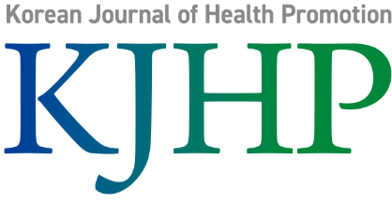
Copyright Transfer Agreement

Manuscript Title:

Authors:

On behalf of all authors of the manuscript entitled as above, I, as a corresponding author, certify that this article is an original work and that none of the material in the manuscript has been published previously or will be published. The authors warrant that they have obtained permission from the copyright holder to reproduce any materials and media including printed and electronic forms not owned by the authors, and that they have acknowledged the source.

Also, all the authors of this manuscript declare that there is no commercial association (e.g., financial interest, stock ownership, consultancy, patent and licensing agreement, etc.) that might pose a conflict of interest in relation to the submitted manuscript.

On behalf of all the authors, I hereby transfer, convey, and assign all copyrights in the Article to the Korean Journal of Health Promotion (KJHP). Also, the copyright to the Contribution identified above is transferred to the KJHP. The copyright transfer covers the right to print, publish, distribute, and sell throughout the world the said Contribution and parts thereof, including all revisions or versions and future editions, in all forms and media expression – such as in its electronic form (offline, online) – now known or developed in the future, as well as to translate, print, publish, distribute, and sell the Contribution in any foreign languages and throughout the world.
Name of Corresponding Author:
Signature of Corresponding Author on behalf of All Authors:
Date: / /

